Project Deliverable 5
PCB Layout design-part II
Semester | : | Spring | Year | : | 2026
Course Title | : | Electronic System Design + Lab
Course Code | : | ECET297
Instructor(s) | :
(Includes names of all instructors teaching this course) | :
Submission Date | :
To be completed by the student
Student Names | :
Student IDs | : |  | Department | :
Major | : |  | Section | :
Integrity Statement | : | “I affirm that I completed my assignment on my own abiding by the rules in ACM Student Handbook. I did not receive any external help, use any unlawful resources or commit plagiarism.”
Signature | :

Grading Scheme
Question | Earned Points | Max. Points | Question | Earned Points | Max. Points
1 |  | 60 | 6
2 |  | 40 | 7
3 |  |  | 8
4 |  |  | 9
5 |  |  | 10

Total Earned Points | Total Available Points | Instructor Name
 | 100
Important Notes:
- Any attempt at plagiarism will be reported. All ACM handbook academic misconduct rules will be applied.
- It is the responsibility of the student to submit this online exam paper to the instructed online platform (Moodle, Turnitin)

ECET297 – Capstone Project

Smart irrigation system using Moisture sensor and IC-741

This project involves the design and development of a smart irrigation system to monitor soil conditions and activate a water pump when the soil moisture falls below a specific threshold. The circuit is used to create an efficient solution for watering plants, by ensuring that the water pump is only activated when the soil becomes dry.

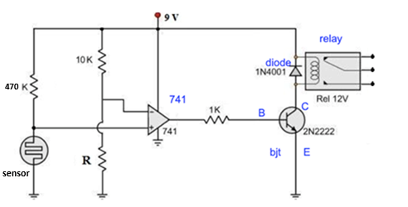

Project Deliverable 5
PCB Layout design-part II

- Boad Design (60 pts)

- Create a new board on easyeda
- The dimensions of the board are 100mm x 70mm
- Place the components and connect them according to the schematics.
- The traces should all be on the bottom layer with a width of 1 mm
- Take screenshot of the designed board and place it below

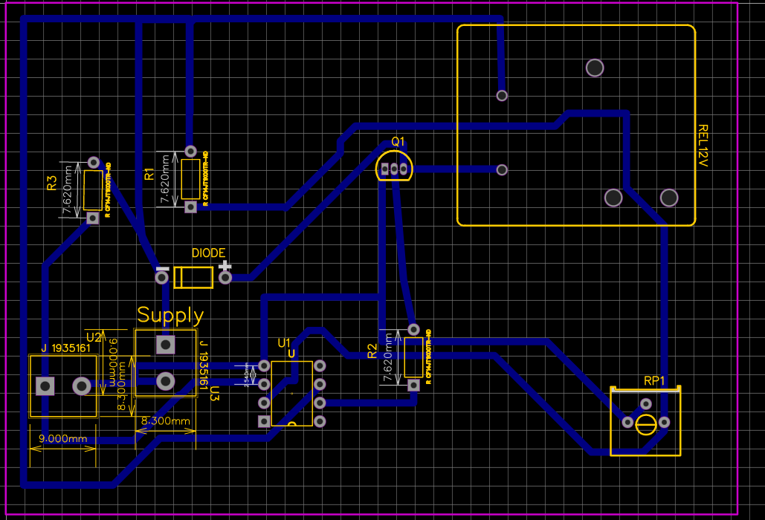

- Gerber files and gerber viewer (40 pts)
  - Gerber files (20 pts)
- Generate Gerber files for the designed board.
- Place a screenshot of the Gerber files below

  - Gerber viewer (20 pts)

- Use online Gerber-viewer website to show all and place a screenshot below



